Jade Pearl
COSC 320-001 Lab 05: Binary Search Trees 3/9/2023

Lab report: I have completed this lab in approximately 2 hours with the help of a student tutor to fix errors found in my code.

Pre-lab:
- Review the information about binary search tree
- Finish implementation of the class integer in int.h file:
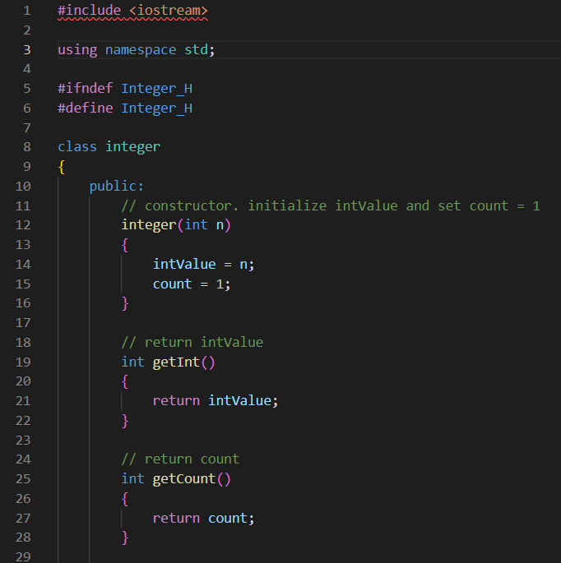
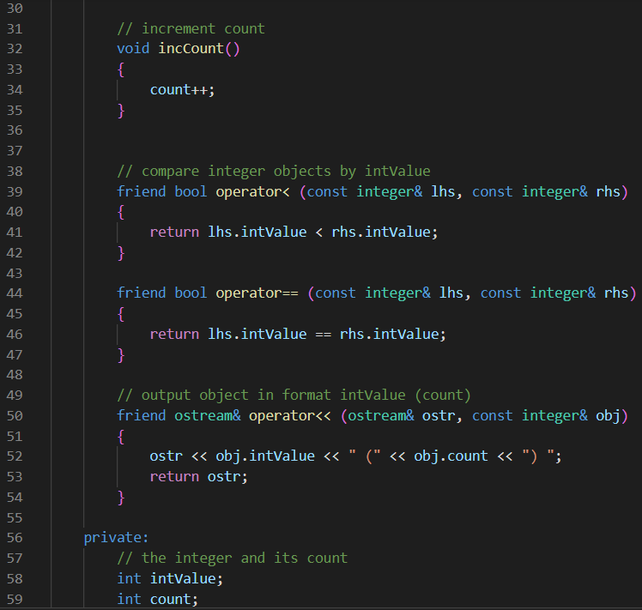
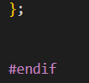
Files Created:
lab_05.cpp, edited the given file int.h

Lab 5
Exercise 1: Read and understand the header file d_stree.h
Exercise 2: Write a main program that generates 10,000 random integers in the range from 0 to 6. For each value, construct an integer object, and search the tree. If the value is in the tree, increment its count, otherwise, insert the value, with a count of 1. In your program, you need first to declare a binary search tree integerTree using d_stree.h, then search the tree, finally output its nodes in order and picture the tree by calling displayTree():

Source code:
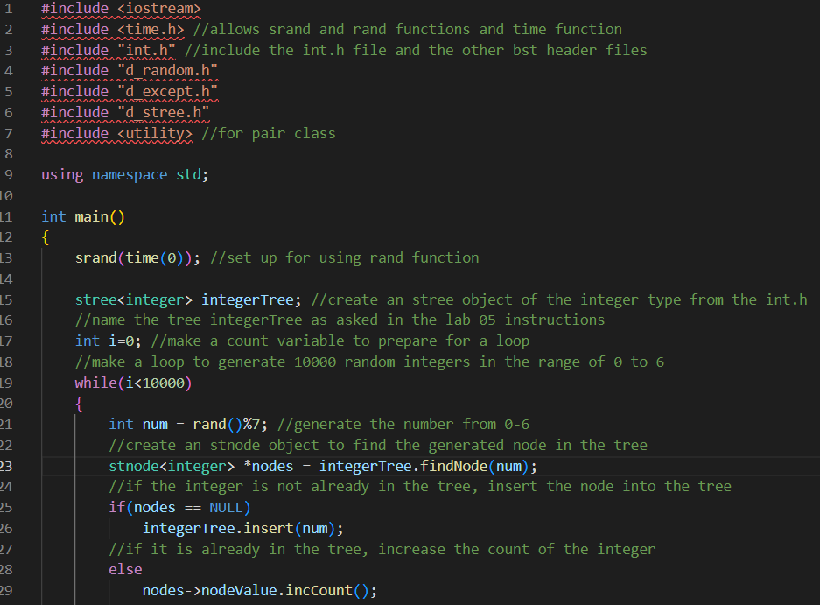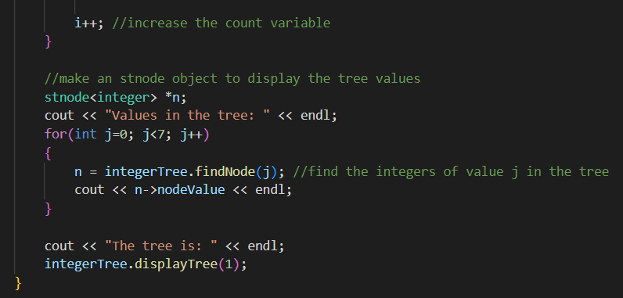
Sample Outputs:
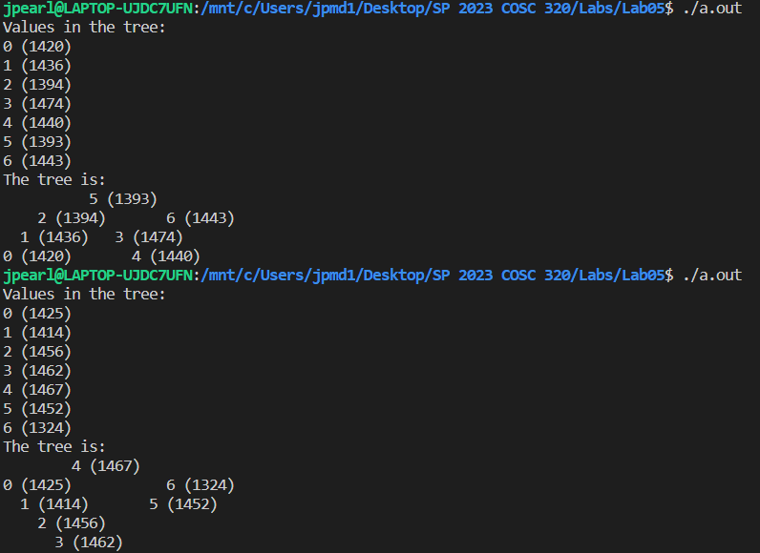
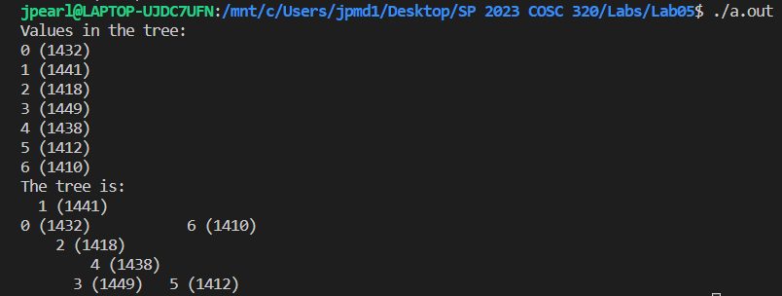

Comparison to lab 04 output:
The output for my lab05 doesn’t seem as sporatic as the output for my lab 04. The tree looks a little more organized in this lab. The nodes in the tree for last lab were very spread out and looked wildly placed with no semblance of organization. In lab 05, the tree looks better put together and the user can tell how the nodes are placed with parent and children.

